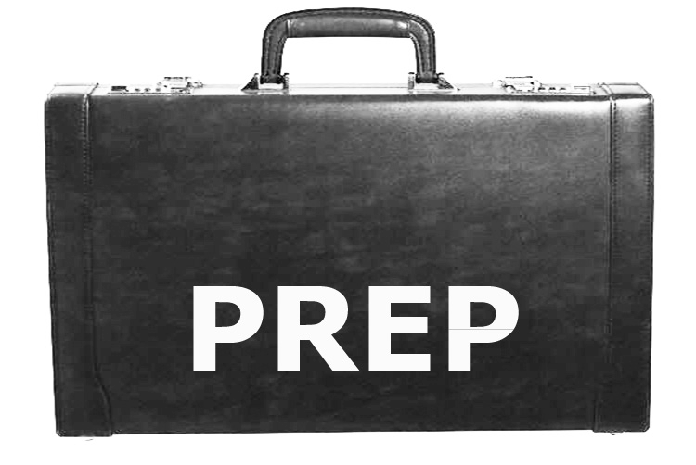

For information, contact the following:

Dressing for the Interview

Are you uncertain about your appearance for job interviews?

PREP will help you:

• Distinguish appropriate dress for
the job search and interview
• Increase your chances of securing employment by presenting yourself in a professional manner
• Use your existing wardrobe to create a more professional appearance
• Learn about community resources that help limited-resource individuals “dress for success”
Sharlean Briggs
Regional Extension Agent
Family Consumer Science
Personal Financial Management
334-382-5111 Office
334-707-8714 Mobile
334-382-3099 Fax

Serving: Autauga, Bibb, Butler, Chilton, Dallas, Elmore, Lowndes, Montgomery, Perry, and Wilcox County.

Published by the Alabama Cooperative Extension System (Alabama A&M University and Auburn University), an equal opportunity educator and employer.

Promoting Readiness for
Employment Possibilities

PREP is designed to provide unemployed and underemployed individuals with the knowledge and skills necessary to achieve employment success

PREP focuses on four major competencies:

Completing Job Applications Resume Building Interviewing Skills
Dressing for the Interview

www.aces.edu
Promoting Readiness for Employment Possibilities

PREParing a Job Application

Do you know how to complete a
written or online job application?

PREP will provide:

• Quick and easy tips to completing
job applications
• Knowledge and skills in electronic job search practices
• Information and resources to improve job hunting strategies
PREParing a Resume

Do you need assistance with preparing a resume that gets attention?

PREP will help you:

• Develop resume writing skills
• Become familiar with the three
types of resumes
• Determine when to use a particular
type of resume
• Learn how to write an eye-catching resume and cover letter
• Create a resume that demonstrates how your skills and abilities are a perfect fit for a position

Increase your employment possibilities
PREParing for the interview

Are you ready to interview for the job?

PREP will help you:

• Develop effective communication skills
• Respond appropriately to basic
interview questions
• Make a good first impression during the interview
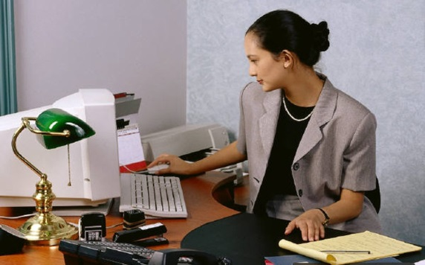
• Follow the proper etiquette during and after the interview

